For SHA KEY



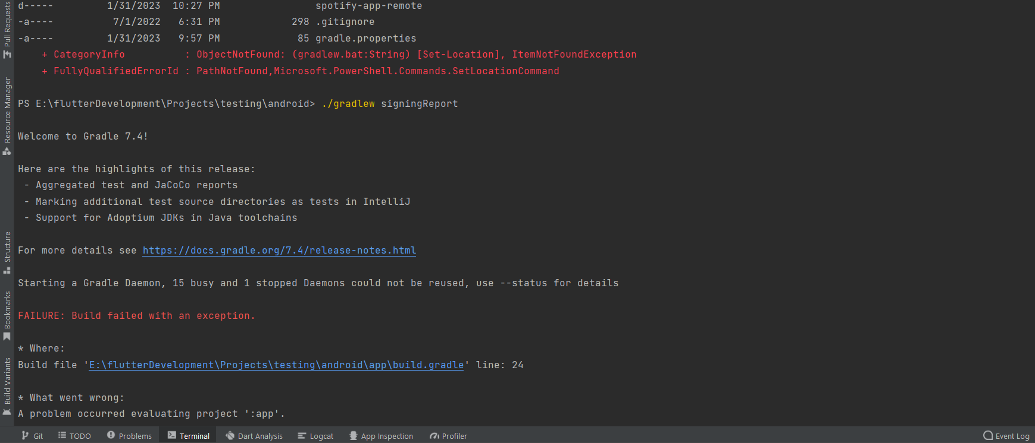

<https://developer.spotify.com/documentation/android/quick-start/?ref=morioh.com&utm_source=morioh.com>

<https://morioh.com/p/2cefe15f9b89>

spotify auth flutter

https://stackoverflow.com/questions/42663114/keystore-file-does-not-exist